

MATHEMATICS
Methods Units 1 & 2

Test 7 – Differentiation

Chapter 8
Semester 2 2019

Section One - Calculator Free

Time allowed for this section
Working time for this section: 25 minutes
Marks available: 24 marks

Material required/recommended for this section

To be provided by the supervisor
This Question/Answer booklet
Formula sheet

To be provided by the students
Standard items: pens, pencils, pencil sharpener, eraser, correction fluid, ruler, highlighters

Special items: Nil

Important note to students
No other items may be used in this section of the assessment. It is your responsibility to ensure that you do not have any unauthorised notes or other items of a non-personal nature in the assessment room. If you have any unauthorised material with you, hand it to the supervisor before reading any further.

- (5 marks)
Sketch the graph of a function that satisfies all of the conditions below. You do not need to determine the equation of such a function.
- The function cuts the x axis at (-6,0), (-2,0) and (2,0)
- The gradient of the function is zero at x = -4 , x = 0 and x = 4
- The gradient is positive for x < -4, 0 < x < 4, x > 4
- The gradient is negative for -4 < x < 0
- The graph cuts the y axis at -5

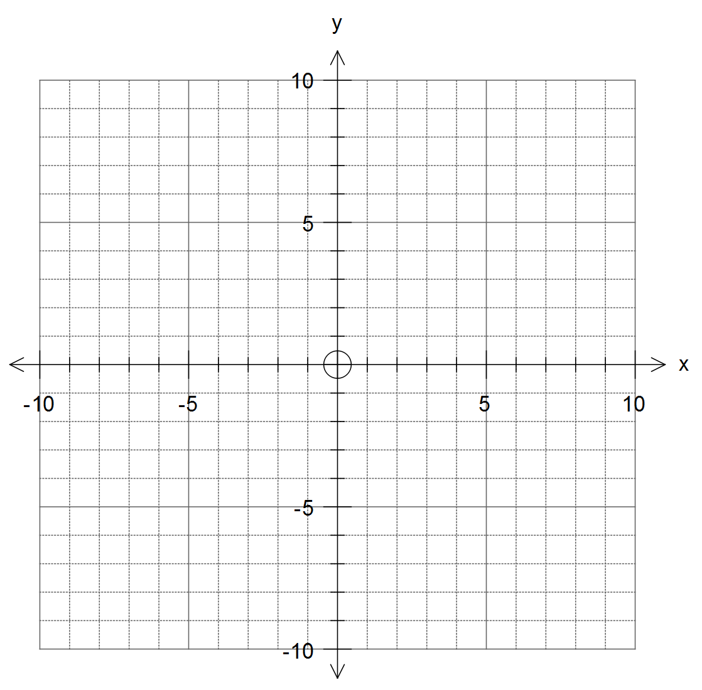

2. (8 marks)
Find the derivative of each of the following functions.
- y = 3x⁴ [1]

- y = 3x² – 2x + 5 [2]

- y = (2x² – x + 3)(4x – 5) [3]

- 2y = 4x² + 6x - 8 [2]

- (7 marks)
Given
a. Find the gradient of the tangent to . [3]

b. Find the equation of the tangent at . [4]

- (4 marks)
The graph of a function is shown below.
Use it to sketch a graph of the corresponding gradient function.
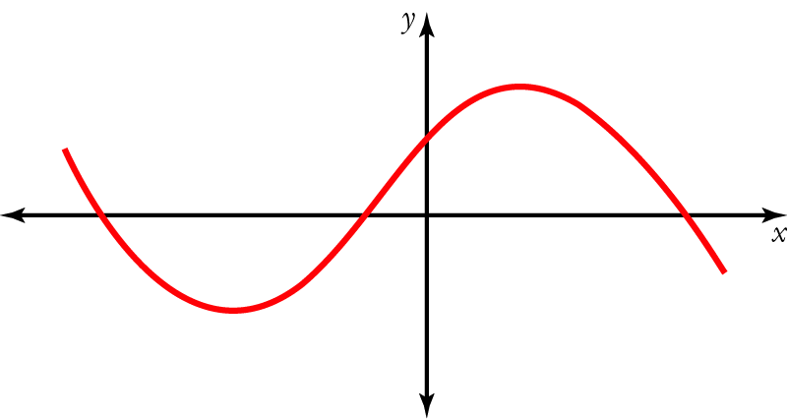

End of Section One

